

Darshan University

A Project Report on

**“Loan Management System”**

Under the subject

**Software Engineering (2101CS503)**

B. Tech, Semester – VI

Computer Science & Engineering Department

|  |  |
| --- | --- |
| Submitted By | |
| Student Name: Jay Ramani | Enrollment No.: 22010101478 |
| Academic Year  (2023-2024) | |
| Internal Guide  Prof. Rajkumar Gondaliya  Darshan University | Dean-DIET  Dr. Gopi Sanghani  Darshan University |

|  |  |
| --- | --- |
|  | **Computer Science & Engineering Department**  **Darshan University** |

**DECLARATION**

We hereby declare that the SRS, submitted along with the **Software Engineering** **(2101CS503)** for entitled **“Loan Management System”** submitted in partial fulfilment for the Semester-5 of **Bachelor Technology (B. Tech)** in **Computer Science and Engineering (CSE)** Departmentto Darshan University, Rajkot, is a record of the work carried out at **Darshan University, Rajkot** under the supervision of **Prof. Rajkumar Gondaliya** and that no part of any of report has been directly copied from any students’ reports, without providing due reference.

Jay Ramani

Student’s Signature

Date: __________

|  |  |
| --- | --- |
|  | **Computer Science & Engineering Department**  **Darshan University** |

**CERTIFICATE**

This is to certify that the SRS on **“Loan Management System” has** been satisfactorily prepared by **Jay Ramani** (22010101478) under my guidance in the fulfillment of the course **Software Engineering (2101CS503)** work during the academic year 2023-2024.

|  |  |  |
| --- | --- | --- |
| Internal Guide  Prof. Rajkumar Gondaliya  Darshan University |  | Dean-DIET  Dr. Gopi Sanghani  Darshan University |

**Acknowledgement**

I wish to express my sincere gratitude to my project guide **Prof.** **Rajkumar Gondaliya** and all the faculty members for helping me through my project by giving me the necessary suggestions and advice along with their valuable co- ordination in completing this work.

I also thank my parents, friends and all the members of the family for their precious support and encouragement which they had provided in completion of my work. In addition to that, I would also like to mention the Darshan University personals who gave me the permission to use and experience the valuable resources required for the project from the University premises.

Thus, in conclusion to the above said, I once again thank the faculties and members of **Darshan University** for their valuable support in completion of the project.

Thanking You

**Jay Ramani**

**ABSTRACT**

This project aims to develop a Loan Management System (LMS) to streamline and automate loan processing, management, and record-keeping for financial institutions. The proposed system will address the limitations of manual processes by establishing a centralized digital platform for loan applications, approvals, tracking repayments, and generating reports. The LMS will offer functionalities for both customer and administrator users. Customers can submit loan applications, access loan details, and schedule payments. Administrators will manage user accounts, loan products, interest rates, process applications, track delinquencies, and generate comprehensive reports for informed decision-making. This user-friendly and secure system will enhance operational efficiency, improve customer service, and minimize errors associated with manual loan management.

Develop an LMS to automate loan processes for financial institutions, boosting profitability through efficiency.

**Table of Contents**

List of Figures I

List of Tables II

1 Introduction 1

1.1 Product perspective 1

1.2 Product features 1

1.2.1 User Types 1

1.2.2 Loan Applicant Features 1

1.2.3 Loan Officer Features 1

1.2.4 Loan Manager Features 1

1.2.5 Admin Features 1

1.3 Functional Requirement 2

1.3.1 Loan Applicant Requirements 2

1.3.2 Loan Officer Requirements 2

1.3.3 Loan Manager Requirements 3

1.3.4 Admin Requirements 3

1.4 Non-Functional Requirement 3

1.4.1 **Usability**: 3

1.4.2 **Accuracy**: 3

1.4.3 **Availability**: 3

1.4.4 **Maintainability**: 3

1.4.5 **Security Audits**: 3

2 Design and Implementation Constraints 4

2.1 Use case diagram 4

2.2 Activity diagram and Swimlane diagram 5

2.2.1 Activity diagram and Swimlane diagram for Loan Application/Apply Process 5

2.2.2 Activity diagram and Swimlane diagram for Loan Approval Process 7

2.3 Sequence diagram 9

2.3.1 Sequence diagram for Loan Application 9

2.3.2 Sequence diagram for Loan Approval 9

2.4 State diagram 10

2.5 Class diagram 11

2.6 Data flow diagram 12

2.6.1 Context diagram (level-0) 12

2.6.2 DFD Level-1 for Applicant 13

3 External Interface Requirement (Screens) 14

3.1 Screen-1: Landing Page 14

3.2 Screen-2: Services Page 15

3.3 Screen-3: Monthly EMI Calculator 16

3.4 Screen-4: EMI Comparison 17

3.5 Screen-5: Contact Page 18

4 Database design 19

4.1 List of Tables 19

5 Stories and Scenario 21

5.1 Story-1: Apply for a New Loan 21

5.1.1 Scenario# S1.1 21

5.1.2 Scenario# S1.2 21

5.1.3 Scenario# S1.3 21

5.1.4 Scenario# S1.4 22

5.1.5 Scenario# S1.5 22

5.2 Story-2: Review and Approve Loan Applications 22

5.3 Story-3: Manage Loan Repayment Schedules 22

5.4 Story-4: Generate Loan Reports 23

5.5 Story-5: Update Applicant Information 23

6 Test cases 24

7 References 44

# List of Figures

Figure 2.1‑1 Use case diagram for loan management system 4

Figure 2.2‑1 Activity diagram for Loan Application 5

Figure 2.2‑2 Swimlane diagram for Loan Application 6

*Figure 2.3‑1 Sequence diagram for Loan Application* 9

Figure 2.4‑1 State diagram of Loan Application 10

Figure 2.5‑1 Class diagram for Loan Management System 11

Figure 2.6‑1 Context diagram (level-0) for Loan Management System 12

Figure 2.6‑2 DFD level-1 for Loan Management System for Applicant 13

Figure 3.1‑1 Screen-1: Landing Page 14

Figure 3.2‑1 Screen-2: Services Page 15

Figure 3.3‑1 Screen-3: Monthly EMI Calculator 16

Figure 3.4‑1 Screen-4: EMI Comparison 17

Figure 3.5‑1 Screen-5: Contact Page 18

# List of Tables

Table 3.1‑1 Screen element of Landing Page 14

Table 3.2‑1 Screen element of Services Page 15

Table 3.3‑1 Screen element of Monthly EMI Calculator 16

Table 3.4‑1 Screen element of EMI Comparison 17

Table 3.5‑1 Screen element of Contact Page 18

Table 4.1‑1 Table: Applicants 19

Table 4.1‑2 Table: Applications 19

Table 4.1‑3 Table: Staff 19

Table 4.1‑4 Table: Reports 20

Table 4.1‑5 Table: Payments 20

# Introduction

## Product perspective

This project aims to develop a Loan Management System (LMS) to automate and centralize loan processing, management, and record-keeping for financial institutions. Replacing manual processes with a secure web application, the LMS improves efficiency, reduces errors, and enhances customer service. The system caters to four user roles: Loan Applicants, Loan Officers, Loan Supervisors, and Admin, streamlining the loan lifecycle from application to repayment.

## Product features

### User Types

* **Loan Applicant:**
  + Individuals applying for and managing loans.
* **Loan Officer:**
  + Processes loan applications, conducts initial assessments, and makes recommendations.
* **Loan Manager:**
  + Reviews and approves/rejects loan applications based on officer recommendations and established criteria.
* **Admin:**
  + Manages system configuration, user accounts, and security protocols.

### Loan Applicant Features

* Secure online loan application submission with document upload.
* Real-time application status tracking.
* Access to loan details, including interest rate, repayment schedule, and remaining balance (once a loan is approved).
* Online payment processing for convenient loan repayments (once a loan is approved).
* Secure communication portal for inquiries and support.

### Loan Officer Features

* User management for creating borrower profiles.
* Configurable loan product selection based on borrower eligibility.
* Access to credit bureau reports and other borrower data for initial assessment.
* Recommendation system for loan approval/rejection with supporting documentation.

### Loan Manager Features

* Review loan applications submitted by Loan Officers, including borrower information, financial details, and recommendations.
* Authority to approve or reject loan applications based on established criteria.
* Access to detailed decision reports for each loan application.

### Admin Features

* System configuration, including setting up loan products, interest rates, and user access controls.
* User management for creating and managing Loan Officer and Loan Supervisor accounts.
* Robust reporting and analytics for overall loan portfolio performance and risk management.
* Secure data storage and access control to ensure borrower privacy and regulatory compliance.

## Functional Requirement

### Loan Applicant Requirements

* **Login/Logout**: Applicants can log in and log out of the system.
* **Submit Application:** Electronically submit loan applications with clear instructions.
* **Upload Documents:** Attach required documents (proof of income, ID) for loan application.
* **Track Status:** Monitor application status in real-time for informed decisions.
* **View Loan Details:** Access loan details (interest rate, repayment schedule, remaining balance) upon approval.
* **Make Payments:** Initiate loan repayments online using various payment options (e.g., bank transfer, debit card).
* **Contact Loan Officer:** Securely communicate with Loan Officers for inquiries and support.
* **Update Profile:** Maintain profile accuracy by updating personal information within the system.
* **Explore Products:** View available loan products and eligibility criteria to choose the best fit.
* **Receive Updates:** Get notified regarding application status updates (e.g., approval, rejection, additional information needed).
* **Download Statements:** Download loan statements and repayment history for record-keeping.
* **Request Restructuring:** If needed, request loan restructuring or extension for unforeseen circumstances.
* **Submit Multiple Applications:** Submit multiple loan applications simultaneously (if applicable).
* **Set Up Auto-Pay:** Set up automatic loan repayments for convenience and timely payments.
* **Dispute Information:** Dispute loan information or fees if discrepancies are found.
* **Provide Feedback:** Help improve the system by providing feedback on functionality and user experience.

### Loan Officer Requirements

* **Review Applications:** Access borrower profiles and application details for comprehensive review.
* **Select Loan Product:** Choose appropriate loan products based on borrower eligibility and financial situation.
* **Verify Financials:** Access credit bureau reports and other borrower financial data for informed decision-making.
* **Recommend Action:** Utilize a recommendation system to suggest loan approval/rejection with supporting documentation.
* **Collaborate with Supervisor:** Collaborate securely with Loan Supervisors through the system for clarification or guidance.
* **Assign Applications:** Assign loan applications to other Loan Officers for review and workload distribution.
* **Generate Reports:** Generate customized reports on loan applications and borrower data for analysis.
* **Communicate with Borrower:** Initiate communication with borrowers regarding application status or missing information.
* **Update Contact Info:** Update borrowers contact information to ensure accurate communication.
* **Access Loan Terms:** Access pre-defined loan terms and conditions for different loan products.
* **Utilize Workflows:** Utilize automated workflows for efficient processing of loan applications.
* **Assess Creditworthiness:** Conduct basic creditworthiness assessments to gauge borrower risk.
* **Credit Check**: Loan officers can perform credit checks on applicants.
* **Customer Feedback Review**: Loan managers can review feedback provided by applicants.

### Loan Manager Requirements

* **Approve Applications:** Review loan applications submitted by Loan Officers.
* **Make Decisions:** Approve or reject loan applications based on established criteria.
* **Access Decision Reports:** Access detailed decision reports for each loan application.
* **Collaborate with Loan Officer:** Securely communicate with Loan Officers for clarification or guidance.
* **Escalate Applications:** Escalate complex loan applications to Admin for review.
* **Analyse Performance:** Access historical loan performance data for trend analysis.
* **View Reports:** View reports on overall loan portfolio performance and risk assessment.
* **Define Workflows:** Define and manage loan approval workflows and escalation procedures.
* **Analyse Officer Performance:** Analyse Loan Officer performance metrics and identify areas for improvement.
* **Control User Accounts:** Manage user accounts and access permissions for Loan Officers.
* **Conduct Audits:** Conduct periodic system audits and ensure compliance with regulations.
* **Generate Supervisor Reports:** Generate customized reports on Loan Supervisor activities and loan performance.
* **Request System Changes:** Initiate system configuration changes with Admin approval.

### Admin Requirements

* **Backups & Recovery:** Implement system backup and disaster recovery procedures.
* **Define User Roles**: Define user roles, permissions, and access levels within the system.
* **User Handling**: Admins can create, update, and delete user accounts.
* **Audit Logs**: Admins can access and manage system audit logs.
* **System Maintenance**: Admins can schedule and perform system maintenance tasks.
* **API**: Admins can manage API access and integrations with external systems.
* **Usage Analytics**: Admins can analyse system usage and generate insights for improvement.

## Non-Functional Requirement

### **Usability**:

* The UI should be simple enough for everyone to understand and get the relevant information without any special training. Different languages can be provided based on the requirements.

### **Accuracy**:

* The data stored about the books and the fines calculated should be correct, consistent, and reliable.

### **Availability**:

* The System should be available for the duration when the library operates and must be recovered within an hour or less if it fails. The system should respond to the requests within two seconds or less.

### **Maintainability**:

* The software should be easily maintainable and adding new features and making changes to the software must be as simple as possible. In addition to this, the software must also be portable.

### **Security Audits**:

* Conduct system audits and ensure adherence to security protocols.

# Design and Implementation Constraints

## Use case diagram

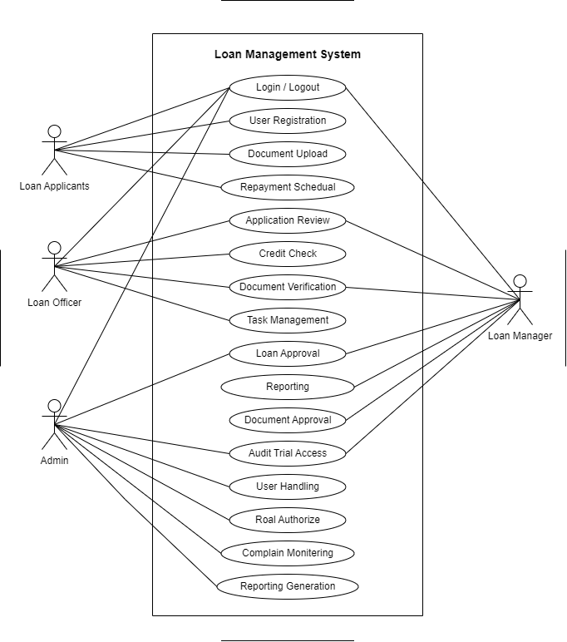

Figure 2.1‑1 Use case diagram for loan management system

## Activity diagram and Swimlane diagram

### Activity diagram and Swimlane diagram for Loan Application/Apply Process

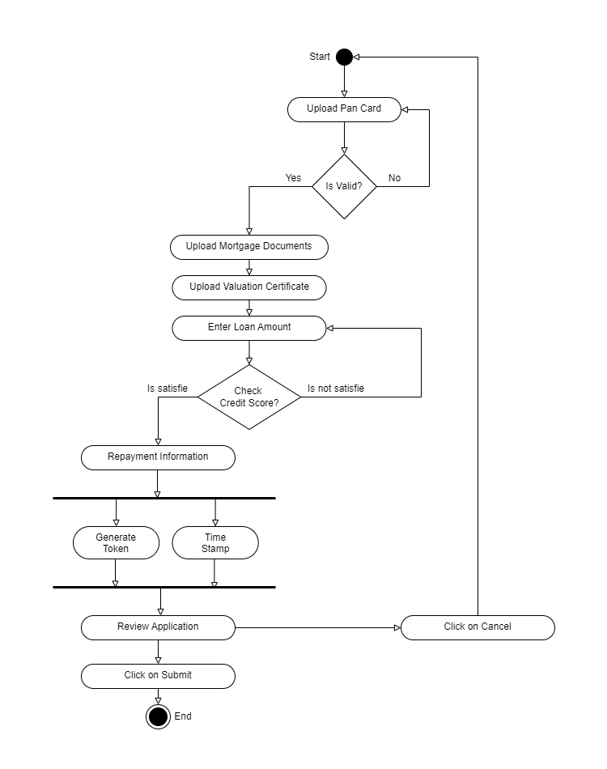

Figure 2.2‑1 Activity diagram for Loan Application

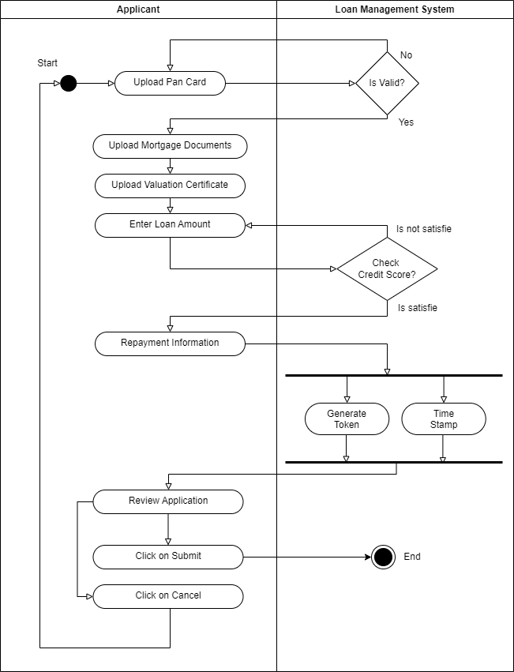

Figure 2.2‑2 Swimlane diagram for Loan Application

### Activity diagram and Swimlane diagram for Loan Approval Process

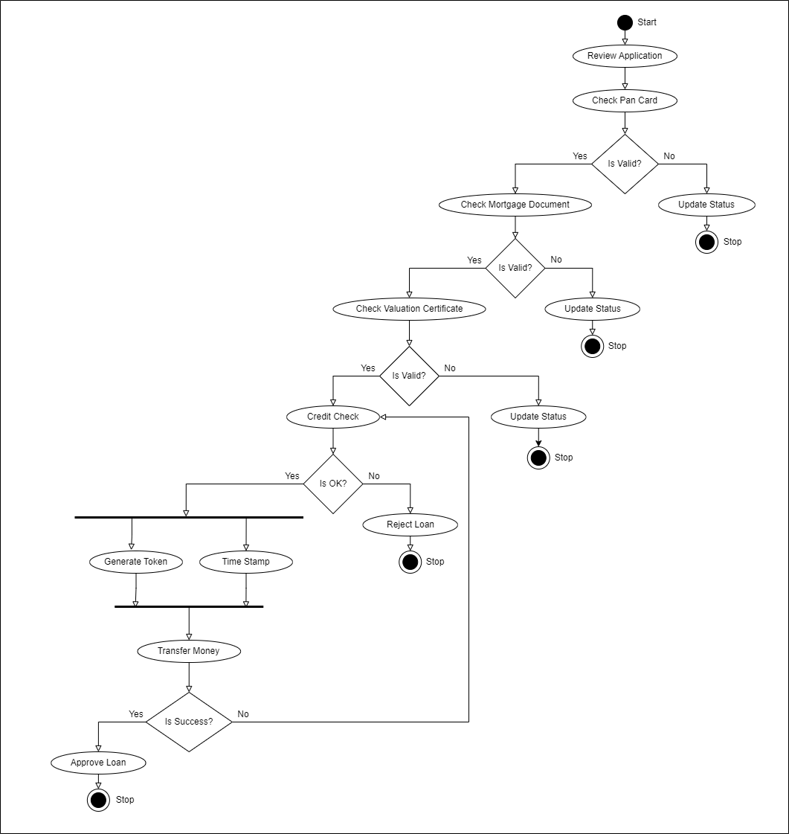

Figure 2.22‑3 Activity diagram for Loan Approval

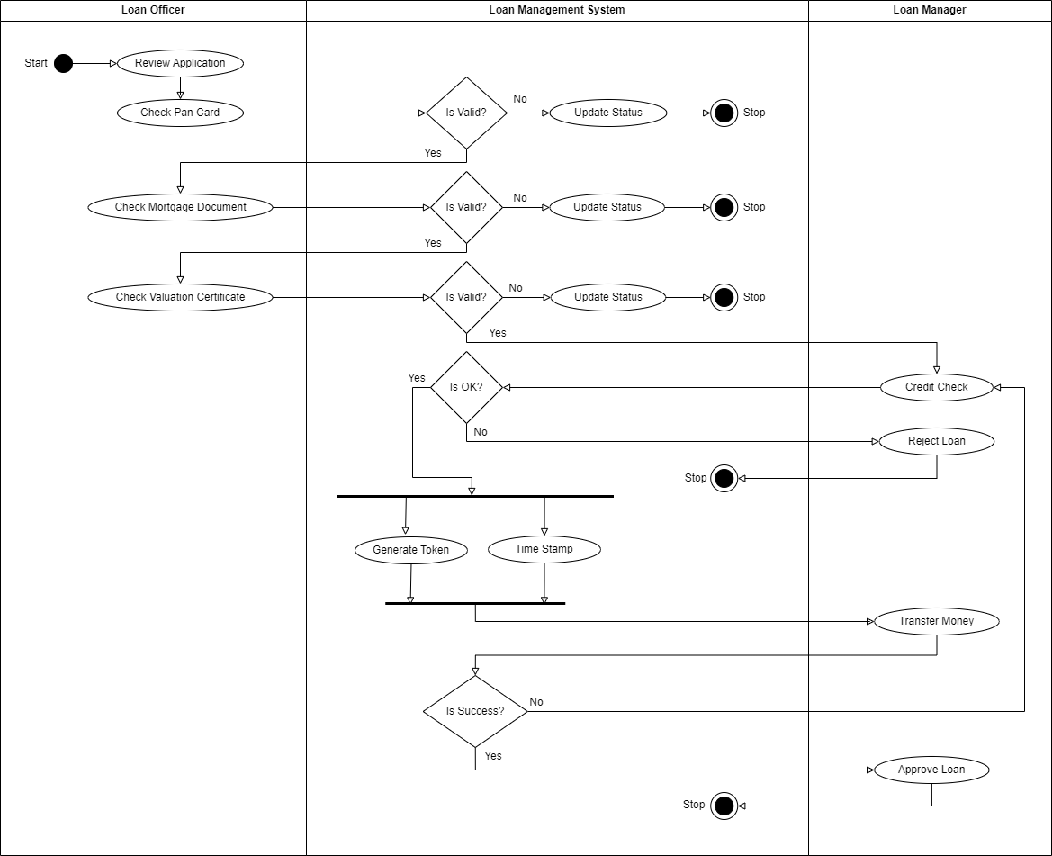

Figure 2.22‑4 Swimlane diagram for Loan Approval

## Sequence diagram

### Sequence diagram for Loan Application

*Figure 2.3‑1 Sequence diagram for Loan Application*

### Sequence diagram for Loan Approval

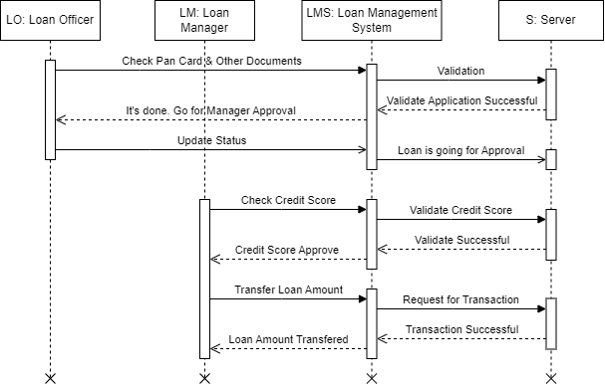

*Figure 2.3‑2 Sequence diagram for Loan Approval*

## State diagram

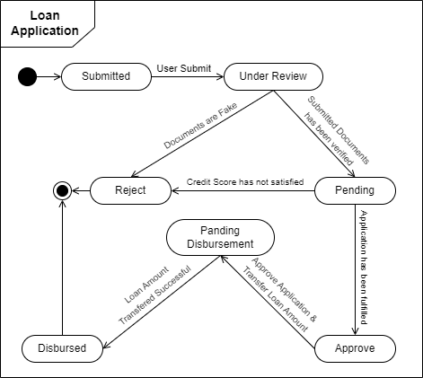

Figure 2.4‑1 State diagram of Loan Application

## Class diagram

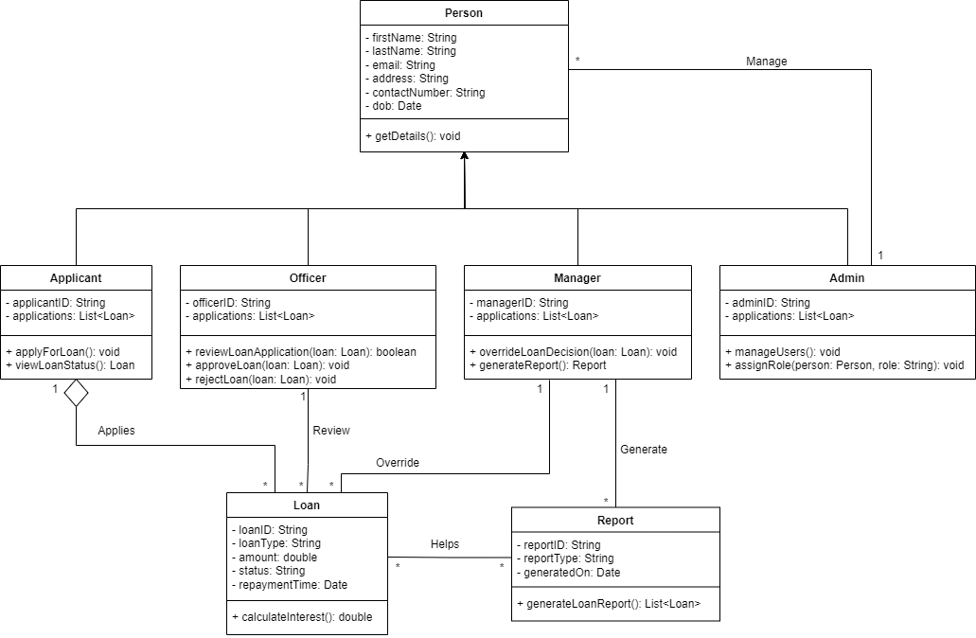

Figure 2.5‑1 Class diagram for Loan Management System

## Data flow diagram

### Context diagram (level-0)

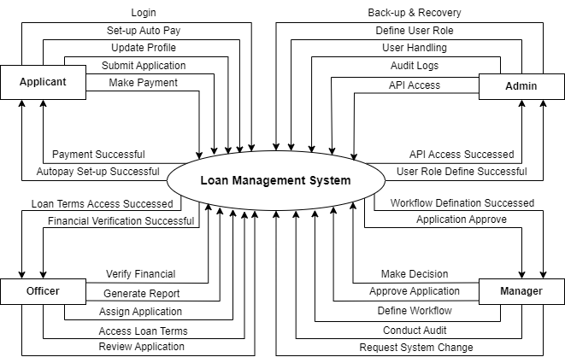

Figure 2.6‑1 Context diagram (level-0) for Loan Management System

### DFD Level-1 for Applicant

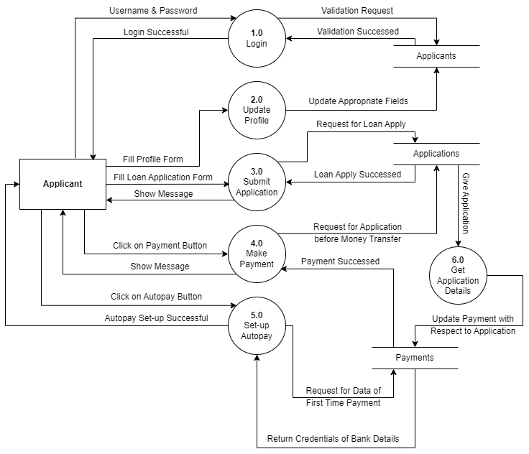

Figure 2.6‑2 DFD level-1 for Loan Management System for Applicant

# External Interface Requirement (Screens)

## Screen-1: Landing Page



Figure 3.1‑1 Screen-1: Landing Page

**Purpose:** It is a lending page to give best experience of users which have to stay connected with us.

Table 3.1‑1 Screen element of Landing Page

|  |  |  |  |  |  |
| --- | --- | --- | --- | --- | --- |
| Sr. | Screen Element | Input Type | O/M | 1/N | Description |
| 1 | Logo | Image | M | 1 | Company Logo |
| 2 | Navigation Items | Links | M | N | All the items of use to navigations. |
| 3 | Background Carousel | Image | M | N | Carousel effect with animation to change images. |
| 4 | Heading | Text | M | 1 | Main page heading. |
| 5 | Description | Text | M | 1 | A sort of description about the loan company. |
| 6 | Button | Button | O | 1 | To navigate user from Apply for Loan section or page. |

## Screen-2: Services Page



Figure 3.2‑1 Screen-2: Services Page

**Purpose:** This page to help to user for understanding services to provide Loan company.

Table 3.2‑1 Screen element of Services Page

|  |  |  |  |  |  |
| --- | --- | --- | --- | --- | --- |
| Sr. | Screen Element | Input Type | O/M | 1/N | Description |
| 1 | Title | Text | M | 1 | Page title |
| 2 | Card | Card | M | N | Each card has the image, name and description about each loan services. |
| 3 | Service Image | Image | M | 1 | Image of Service. |
| 4 | Icon | Icon | M | 1 | Related icon of service. |
| 5 | Service Name | Text | M | 1 | Name of service. |
| 6 | Service Description | Text | O | 1 | Short description about service. |
| 7 | Button | Button | M | 1 | Help to user to navigate specific service page. |

## Screen-3: Monthly EMI Calculator

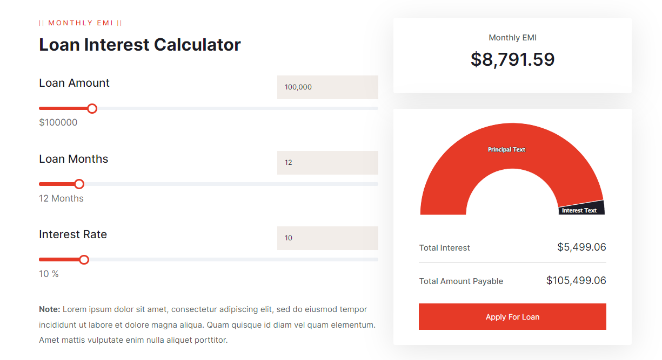

Figure 3.3‑1 Screen-3: Monthly EMI Calculator

**Purpose:** To calculate monthly EMI before applying the Loan.

Table 3.3‑1 Screen element of Monthly EMI Calculator

|  |  |  |  |  |  |
| --- | --- | --- | --- | --- | --- |
| Sr. | Screen Element | Input Type | O/M | 1/N | Description |
| 1 | Heading | Text | M | 1 | Heading of the calculator |
| 2 | Loan Amount | Range | M | 1 | To set loan amount. |
| 3 | Months | Range | M | 1 | To get for how many months. |
| 4 | Rate | Range | M | 1 | To set the interest rate. |
| 5 | Description | Text | O | 1 | If any conditions for user, put it here. |
| 6 | Monthly EMI | Text | M | 1 | Calculate Monthly EMI based on user input. |
| 7 | Statistics | Graph | O | 1 | Showing visually principal amount and interest amount |
| 8 | Total Interest | Text | M | 1 | Showing the total interest. |
| 9 | Payable Amount | Text | M | 1 | Showing the total payable amount. |
| 10 | Button | Button | M | 1 | Navigate to Apply for Loan section. |

## Screen-4: EMI Comparison

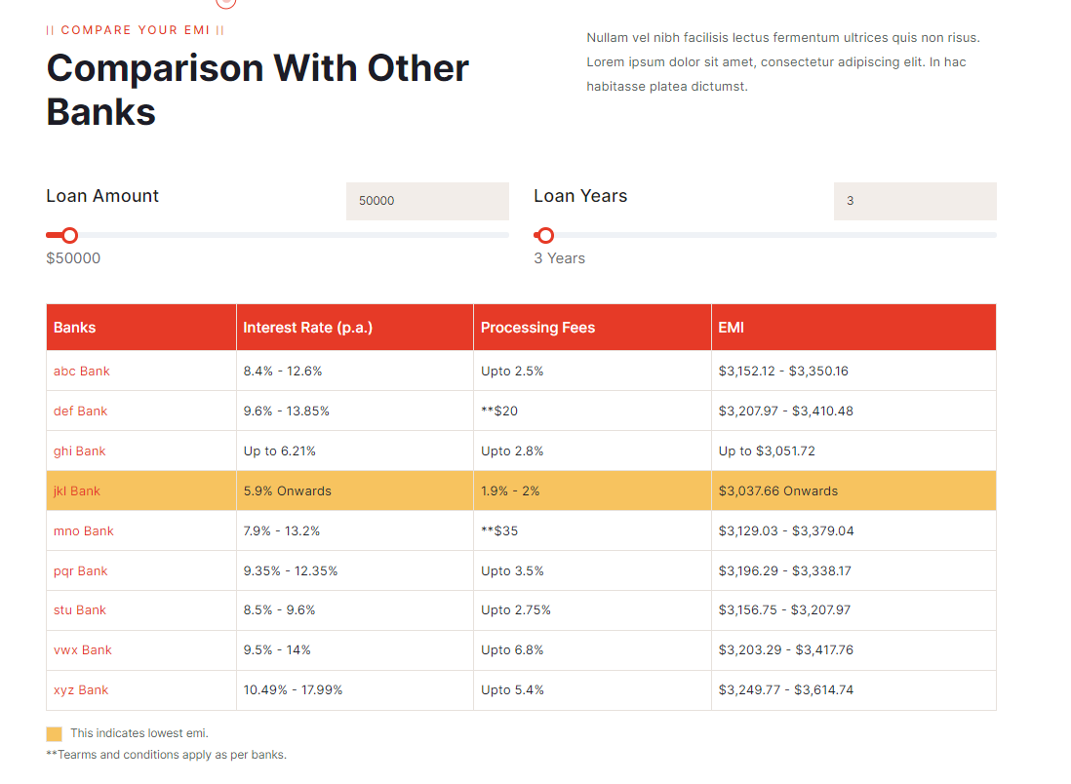

Figure 3.4‑1 Screen-4: EMI Comparison

**Purpose:** Comparison the Interest of the one bank to another bank.

Table 3.4‑1 Screen element of EMI Comparison

|  |  |  |  |  |  |
| --- | --- | --- | --- | --- | --- |
| Sr. | Screen Element | Input Type | O/M | 1/N | Description |
| 1 | Heading | Text | M | 1 | Heading of the section |
| 2 | Description | Text | O | 1 | If any conditions or extra charges for user, put it here. |
| 3 | Loan Amount | Range | M | 1 | To set loan amount. |
| 4 | Year | Range | M | 1 | To get for how many years. |
| 5 | Table | Table | M | 1 | Comparison table for so many banks’ interest rate with EMI |

## Screen-5: Contact Page

Figure 3.5‑1 Screen-5: Contact Page

**Purpose:** This form will allow the users to connect with us.

Table 3.5‑1 Screen element of Contact Page

|  |  |  |  |  |  |
| --- | --- | --- | --- | --- | --- |
| Sr. | Screen Element | Input Type | O/M | 1/N | Description |
| 1 | Heading | Text | M | 1 | Heading of the section |
| 2 | Description | Text | O | 1 | Description of this section. |
| 3 | Icons | Icon | M | N | Many more social media where connect the user easily. |
| 4 | Full Name | Textbox | M | 1 | Name field should be editable and accept the Name. |
| 5 | Email | Textbox | M | 1 | Email field should be editable and accept the email with proper format. |
| 6 | Phone Number | Textbox | M | 1 | Phone number field should be accepted by the user with proper format. |
| 7 | Subject | Textbox | M | 1 | Who is the main objective to message. Accept for this purpose. |
| 8 | Message | Text area | M | 1 | Message field should be accepting the message of user. User what to say? |
| 9 | Button | Button | M | 1 | Button which must click after message reach out of company’s dashboard. |

# Database design

## List of Tables

* Applicants
* Applications
* Staff
* Reports
* Payments

Table 4.1‑1 Table: Applicants

|  |  |  |  |  |
| --- | --- | --- | --- | --- |
| Column | Data Type | Null | Keys & Constrains | Default Value & Description |
| ApplicantID | Int | NN | PK (Auto Increment) | - |
| ApplicantName | Varchar(250) | NN | - | - |
| ApplicantAge | Int | NN | - | - |
| ApplicantContact | Varchar(10) | NN | - | - |
| ApplicantEmail | Varchar(100) | NN | - | - |
| ApplicantAddress | Varchar(750) | AN | - | - |
| ApplicantPanCardNumber | Varchar(10) | NN | - | - |
| ApplicantApplications | Array(ApplicationID) | AN | FK | Reference of Applications Table |

Table 4.1‑2 Table: Applications

|  |  |  |  |  |
| --- | --- | --- | --- | --- |
| Column | Data Type | Null | Keys & Constrains | Default Value & Description |
| ApplicationID | Int | NN | PK (Auto Increment) | - |
| ApplicantID | Int | NN | FK | Reference of Applicants Table |
| MortageDocument | Varchar(250) | NN | - | - |
| ValuationCertificate | Varchar(250) | NN | - | - |
| LoanAmount | Decimal(10, 2) | NN | - | - |
| ApplicationStatus | Varchar(20) | AN | - | - |
| isAutoRepayment | Boolean | NN | - | - |

Table 4.1‑3 Table: Staff

|  |  |  |  |  |
| --- | --- | --- | --- | --- |
| Column | Data Type | Null | Keys & Constrains | Default Value & Description |
| StaffID | Int | NN | PK (Auto Increment) | - |
| StaffRole | Varchar(20) | NN | - | - |
| AssginApplications | Array(ApplicationID) | AN | FK | Reference of Applications Table |
| StaffName | Varchar(250) | NN | - | - |
| StaffAge | Int | NN | - | - |
| StaffContact | Varchar(10) | NN | - | - |
| StaffEmail | Varchar(100) | NN | - | - |
| ApplicantAddress | Varchar(750) | AN | - | - |

Table 4.1‑4 Table: Reports

|  |  |  |  |  |
| --- | --- | --- | --- | --- |
| Column | Data Type | Null | Keys & Constrains | Default Value & Description |
| ReportID | Int | NN | PK (Auto Increment) | - |
| ApplicationID | Int | NN | FK | Reference of Application Table |
| CreditScoreAmount | Decimal(9,2) | AN | - | - |
| PaymentsRegularization | Array(PaymentID) | AN | FK | Reference of Payments Table |

Table 4.1‑5 Table: Payments

|  |  |  |  |  |
| --- | --- | --- | --- | --- |
| Column | Data Type | Null | Keys & Constrains | Default Value & Description |
| PaymentID | Int | NN | PK (Auto Increment) | - |
| ApplicationID | Int | NN | FK | Reference of Application Table |
| PendingAmount | Decimal(9,2) | AN | - | - |
| PaymentMode | Varchar(20) | NN | - | - |
| ReferenceID | Varchar(250) | NN | - | - |
| PayementDate | Datetime | NN | - | - |

# Stories and Scenario

## Story-1: Apply for a New Loan

|  |  |  |
| --- | --- | --- |
| *Story # S1* | : | As a Loan Applicant, I want to apply for a new loan online, So that I can conveniently submit my loan application without visiting the bank. |
| Priority | **:** | High |
| Estimate | **:** | XL |
| Reason | **:** | Allowing applicants to apply for loans online is crucial for enhancing customer experience and streamlining the loan approval process. |

### Scenario# S1.1

|  |  |  |
| --- | --- | --- |
| *Scenario# S1.1* | : | Submitting a Loan Application with Valid Information |
| Prerequisite | **:** | The applicant is logged in to the Loan Management System. |
| Acceptance Criteria | **:** | **Given:**  The applicant is on the loan application page and all required fields (personal information, income details, loan amount, etc.) are filled with valid information.  **When:** The applicant clicks the "Submit" button.  **Then t**he system successfully submits the application and displays a confirmation message with the application reference number. |

### Scenario# S1.2

|  |  |  |
| --- | --- | --- |
| *Scenario# S1.2* | : | Submitting a Loan Application with Incomplete Information |
| Prerequisite | **:** | The applicant is logged in to the Loan Management System. |
| Acceptance Criteria | **:** | **Given:** The applicant is on the loan application page but leaves some required fields (like income details) blank or provides invalid data.  **When:** The applicant clicks the "Submit" button.  **Then t**he system displays an error message indicating the missing or incorrect information and does not proceed with the submission. |

### Scenario# S1.3

|  |  |  |
| --- | --- | --- |
| *Scenario# S1.3* | : | Submitting a Duplicate Loan Application |
| Prerequisite | **:** | The applicant is logged in to the Loan Management System, and an application with similar details is already in progress. |
| Acceptance Criteria | **:** | **Given**: The applicant is on the loan application page and enters the same loan amount and details as a previously submitted application.  **When**: The applicant clicks the "Submit" button.  **Then t**he system detects the duplicate application and displays a message stating that an application with the same details is already in progress. |

### Scenario# S1.4

|  |  |  |
| --- | --- | --- |
| *Scenario# S1.4* | : | Loan Application Form Validation |
| Prerequisite | **:** | The applicant is logged in to the Loan Management System. |
| Acceptance Criteria | **:** | **Given**: The applicant is on the loan application form page.  **When**: The applicant attempts to submit the form without filling in the required fields or enters data in an incorrect format (e.g., letters in a numeric field).  **Then t**he system highlights the incorrect fields and displays a message prompting the user to correct the errors. |

### Scenario# S1.5

|  |  |  |
| --- | --- | --- |
| *Scenario# S1.5* | : | Applying for a Loan with Exceeding Credit Limit |
| Prerequisite | **:** | The applicant is logged in to the Loan Management System, and their credit profile is assessed. |
| Acceptance Criteria | **:** | **Given**: The applicant requests a loan amount that exceeds the maximum allowable limit based on their credit profile.  **When**: The applicant clicks the "Submit" button.  **Then t**he system displays a message indicating that the requested loan amount exceeds the credit limit and advises the user to apply for a lower amount. |

## Story-2: Review and Approve Loan Applications

|  |  |  |
| --- | --- | --- |
| *Story # S2* | : | As a Loan Officer, I want to review and approve or reject loan applications, So that I can ensure only eligible applications are processed. |
| Priority | **:** | High |
| Estimate | **:** | M |
| Reason | **:** | Loan officers need to efficiently manage loan approvals to maintain financial security and customer trust. |

## Story-3: Manage Loan Repayment Schedules

|  |  |  |
| --- | --- | --- |
| *Story # S3* | : | As a Loan Manager, I want to manage loan repayment schedules, So that I can track repayments and handle overdue payments effectively. |
| Priority | **:** | High |
| Estimate | **:** | M |
| Reason | **:** | Effective management of loan repayments is critical to maintaining cash flow and minimizing defaults. |

## Story-4: Generate Loan Reports

|  |  |  |
| --- | --- | --- |
| *Story # S4* | : | As an Admin, I want to generate detailed reports on loan status and repayments, So that I can monitor the performance of the loan portfolio. |
| Priority | **:** | Medium |
| Estimate | **:** | L |
| Reason | **:** | Reporting functionality helps in strategic planning and decision-making. |

## Story-5: Update Applicant Information

|  |  |  |
| --- | --- | --- |
| *Story # S5* | : | As a Loan Applicant, I want to update my personal and financial information, So that my loan application reflects my most current details. |
| Priority | **:** | Medium |
| Estimate | **:** | M |
| Reason | **:** | Keeping information up to date is essential for accurate loan processing and reducing the risk of misinformation. |

# Test cases

|  |  |  |  |
| --- | --- | --- | --- |
| Project Name: | Loan Management System | Test Designed by: | Jay Ramani |
| Module Name: | **Loan Application** | **Test Designed date:** | 23-08-2024 |
| Release Version: | **1.0** | **Test Executed by:** | **Jay Ramani** |
|  |  | **Test Execution date:** | 24-08-2024 |

|  |  |  |  |  |
| --- | --- | --- | --- | --- |
| Pre-condition: Web application should be accessible | | | | |
| Test Case ID | **Test Title** | **Test Type** | **Description** | **Test Case ID** |
| TC_001 | Verify Loan Application Form Submission | GUI | Verify that the loan application submission process is functioning correctly with all required fields. | TC_001 |
| TC_002 | Verify Document Upload Functionality | GUI | Ensure that the loan amount field accepts values within a specified range and shows errors for invalid inputs. | TC_002 |
| TC_003 | Verify Loan Amount Validation | Functional | Check that the system calculates the interest rate correctly based on the loan amount and duration. | TC_003 |
| TC_004 | Verify Loan Application Status Check | GUI | Ensure the loan application status is updated correctly at each stage of the process. | TC_004 |

|  |  |
| --- | --- |
| **Test Case Title** | Verify Loan Application Form Submission |
| **Test Type** | Functional |
| **Test Priority** | High |
| **Pre-condition** | Web application should be accessible, and the user should be logged in. |

|  |  |  |  |  |  |  |  |
| --- | --- | --- | --- | --- | --- | --- | --- |
| **Test Step** | **Test Case Description** | **Expected Result** | **Actual Result** | **Status** | **Comment** | **Data** | **BUG ID** |
| 1 | |  | | --- | | Open loan  application  form |  |  | | --- | |  | | Form should load with all fields | Form loaded correctly | Pass |  | N/A |  |
| 2 | Enter valid data in all mandatory fields | System accepts and validates the data | Data validated successfully | Pass |  | N/A |  |
| 3 | Leave one mandatory field blank and try to submit | System should display an error message | Error message displayed | Pass |  | Field: Income |  |
| 4 | Enter invalid characters in a numeric field (e.g., loan amount) | System should not accept invalid characters and show an error | Error message displayed | Pass |  | Amount: abc |  |

|  |  |
| --- | --- |
| **Test Case Title** | Verify Document Upload Functionality |
| **Test Type** | GUI |
| **Test Priority** | Medium |
| **Pre-condition** | Loan application form should be accessible. |

|  |  |  |  |  |  |  |  |
| --- | --- | --- | --- | --- | --- | --- | --- |
| **Test Step** | **Test Case Description** | **Expected Result** | **Actual Result** | **Status** | **Comment** | **Data** | **Bug ID** |
| 1 | Access the document upload section | Section should be visible | Section visible | Pass |  | N/A |  |
| 2 | Attempt to upload a document exceeding the size limit | System should show an error message: "File size too large" | Error message displayed | Pass |  | File size: 20MB |  |
| 3 | Upload a file in an unsupported format (e.g., .exe file) | System should reject the file and display an error | Error message displayed | Pass |  | Format: .exe |  |
| 4 | Upload a valid document (e.g., .pdf, .jpg) | System should accept and save the document | Document uploaded | Pass |  | Format: .pdf |  |

|  |  |
| --- | --- |
| **Test Case Title** | Verify Loan Amount Validation |
| **Test Type** | Functional |
| **Test Priority** | High |
| **Pre-condition** | Loan application form should be accessible. |

|  |  |  |  |  |  |  |  |
| --- | --- | --- | --- | --- | --- | --- | --- |
| **Test Step** | **Test Case Description** | **Expected Result** | **Actual Result** | **Status** | **Comment** | **Data** | **Bug ID** |
| 1 | Enter a loan amount below the minimum allowed limit | System should show an error message: "Amount too low" | Error message displayed | Pass |  | Amount: 500 |  |
| 2 | Enter a loan amount above the maximum allowed limit | System should show an error message: "Amount too high" | Error message displayed | Pass |  | Amount: 1,000,000 |  |
| 3 | Enter a valid loan amount within the allowed range | System should accept the amount | Amount accepted | Pass |  | Amount: 50,000 |  |
| 4 | Enter a loan amount with special characters (e.g., $50,000) | System should not accept the input and show an error | Error message displayed | Pass |  | Amount: $50,000 |  |

|  |  |
| --- | --- |
| **Test Case Title** | Verify Loan Application Status Check |
| **Test Type** | GUI |
| **Test Priority** | Medium |
| **Pre-condition** | Loan application should be submitted. |

|  |  |  |  |  |  |  |  |
| --- | --- | --- | --- | --- | --- | --- | --- |
| **Test Step** | **Test Case Description** | **Expected Result** | **Actual Result** | **Status** | **Comment** | **Data** | **BUG ID** |
| 1 | Submit a loan application | Application submitted successfully | Application submitted | Pass |  | Loan ID: 78945 |  |
| 2 | Check application status immediately after submission | Status should be "Under Review" | Status "Under Review" displayed | Pass |  | N/A |  |
| 3 | After loan officer reviews, check application status again | Status should update to "Approved" or "Rejected" | Status updated to "Approved" | Pass |  | N/A |  |
| 4 | Attempt to check status without logging in | System should prompt the user to log in | Login prompt displayed | Pass |  | N/A |  |

|  |  |  |  |
| --- | --- | --- | --- |
| Project Name: | Loan Management System | Test Designed by: | Jay Ramani |
| Module Name: | **Loan Processing and Approval** | **Test Designed date:** | 25-08-2024 |
| Release Version: | **1.0** | **Test Executed by:** | **Jay Ramani** |
|  |  | **Test Execution date:** | 26-08-2024 |

|  |  |  |  |  |
| --- | --- | --- | --- | --- |
| Pre-condition: Web application should be accessible | | | | |
| Test Case ID | **Test Title** | **Test Type** | **Description** | **Test Case ID** |
| TC_005 | Verify Loan Approval Process | Functional | Confirm that applicants can upload necessary documents in supported formats only. | TC_005 |
| TC_006 | Verify Loan Rejection Process | Functional | Check that the system validates the format of uploaded documents correctly and rejects unsupported formats. | TC_006 |
| TC_007 | Verify Risk Assessment for Loan Approval | Functional | Ensure the system verifies that all required documents are uploaded before proceeding. | TC_007 |
| TC_008 | Verify Loan Document Verification by Officer | Functional | Check that the document approval process correctly updates the application status upon completion. | TC_008 |

|  |  |
| --- | --- |
| **Test Case Title** | Verify Loan Approval Process |
| **Test Type** | Functional |
| **Test Priority** | High |
| **Pre-condition** | Loan application should be submitted and pending approval. |

|  |  |  |  |  |  |  |  |
| --- | --- | --- | --- | --- | --- | --- | --- |
| **Test Step** | **Test Case Description** | **Expected Result** | **Actual Result** | **Status** | **Comment** | **Data** | **BUG ID** |
| 1 | Access loan approval page as a loan officer | Approval page should be accessible | Page accessible | Pass |  | N/A |  |
| 2 | Review all submitted documents and details | All documents and details should be visible and accessible | All details visible | Pass |  | N/A |  |
| 3 | Approve loan application without reviewing all documents | System should prompt an error: "Review all documents before approval" | Error message displayed | Pass |  | N/A |  |
| 4 | Approve loan application after reviewing all documents | Loan status should change to "Approved" | Status updated to "Approved" | Pass |  | N/A |  |

|  |  |
| --- | --- |
| **Test Case Title** | Verify Loan Rejection Process |
| **Test Type** | Functional |
| **Test Priority** | Medium |
| **Pre-condition** | Loan application should be submitted and pending approval. |

|  |  |  |  |  |  |  |  |
| --- | --- | --- | --- | --- | --- | --- | --- |
| **Test Step** | **Test Case Description** | **Expected Result** | **Actual Result** | **Status** | **Comment** | **Data** | **Bug ID** |
| 1 | Access loan rejection page as a loan officer | |  | | --- | | Rejection page should be accessible |  |  | | --- | |  | | Page accessible | Pass |  | N/A |  |
| 2 | Review application details and select the "Reject" option | System should display a confirmation prompt | Confirmation prompt displayed | Pass |  | N/A |  |
| 3 | Reject loan without providing a rejection reason | System should show an error message: "Rejection reason required" | Error message displayed | Pass |  | N/A |  |
| 4 | Provide valid reason and reject loan | Loan status should change to "Rejected" | Status updated to "Rejected" | Pass |  | N/A |  |

|  |  |
| --- | --- |
| **Test Case Title** | Verify Risk Assessment for Loan Approval |
| **Test Type** | Functional |
| **Test Priority** | High |
| **Pre-condition** | Loan application should be in "Under Review" status. |

|  |  |  |  |  |  |  |  |
| --- | --- | --- | --- | --- | --- | --- | --- |
| **Test Step** | **Test Case Description** | **Expected Result** | **Actual Result** | **Status** | **Comment** | **Data** | **Bug ID** |
| 1 | Access risk assessment tool on the loan approval page | Risk assessment tool should be accessible | |  | | --- | | Tool  accessible |  |  | | --- | |  | | Pass |  | |  | | --- | | N/A |  |  | | --- | |  | |  |
| 2 | Perform risk assessment with all valid parameters | System should provide a risk score based on parameters | Risk score generated | Pass |  | |  | | --- | | N/A |  |  | | --- | |  | |  |
| 3 | Attempt risk assessment with missing critical data (e.g., income) | System should display an error: "Incomplete data for risk assessment" | Error message displayed | Pass |  | Income: N/A |  |
| 4 | Approve or reject loan based on risk assessment score | Loan status should change accordingly | Status updated as per risk | Pass |  | |  | | --- | | N/A |  |  | | --- | |  | |  |

|  |  |
| --- | --- |
| **Test Case Title** | Verify Loan Document Verification by Officer |
| **Test Type** | Functional |
| **Test Priority** | Medium |
| **Pre-condition** | Loan application documents should be uploaded by the user. |

|  |  |  |  |  |  |  |  |
| --- | --- | --- | --- | --- | --- | --- | --- |
| **Test Step** | **Test Case Description** | **Expected Result** | **Actual Result** | **Status** | **Comment** | **Data** | **BUG ID** |
| 1 | Access document verification page as a loan officer | Document verification page should be accessible | Page accessible | Pass |  | N/A |  |
| 2 | View each document submitted by the applicant | All documents should be visible for review | Documents visible | Pass |  | N/A |  |
| 3 | Mark a document as "Verified" without reviewing | System should prompt an error: "Review document before marking as verified" | Error message displayed | Pass |  | N/A |  |
| 4 | Review and verify all documents | Documents should be marked as "Verified" successfully | All documents verified | Pass |  | N/A |  |

|  |  |  |  |
| --- | --- | --- | --- |
| Project Name: | Loan Management System | Test Designed by: | Jay Ramani |
| Module Name: | **Loan Repayment and Management** | **Test Designed date:** | 27-08-2024 |
| Release Version: | **1.0** | **Test Executed by:** | **Jay Ramani** |
|  |  | **Test Execution date:** | 28-08-2024 |

|  |  |  |  |  |
| --- | --- | --- | --- | --- |
| Pre-condition: Web application should be accessible | | | | |
| Test Case ID | **Test Title** | **Test Type** | **Description** | **Test Case ID** |
| TC_009 | Verify Loan Repayment Schedule Generation | Functional | Ensure that the system generates a repayment schedule based on loan terms correctly. | TC_009 |
| TC_010 | Verify Loan Prepayment Functionality | Functional | Check that the EMI calculation is accurate as per the agreed interest rate and loan tenure. | TC_010 |
| TC_011 | Verify Loan Overdue Management | Functional | Confirm that the system sends timely payment reminders to borrowers. | TC_011 |
| TC_012 | Verify Automatic Payment Deduction | Functional | Ensure the system applies late payment penalties according to policy rules. | TC_012 |

|  |  |
| --- | --- |
| **Test Case Title** | Verify Loan Repayment Schedule Generation |
| **Test Type** | Functional |
| **Test Priority** | High |
| **Pre-condition** | Loan application should be approved. |

|  |  |  |  |  |  |  |  |
| --- | --- | --- | --- | --- | --- | --- | --- |
| **Test Step** | **Test Case Description** | **Expected Result** | **Actual Result** | **Status** | **Comment** | **Data** | **BUG ID** |
| 1 | Access loan repayment schedule page | Schedule page should be accessible | Page accessible | Pass |  | N/A |  |
| 2 | Generate repayment schedule for a given loan | System should generate and display the repayment schedule | Schedule generated and displayed | Pass |  | |  | | --- | |  |  |  | | --- | | N/A | |  |
| 3 | Attempt to generate schedule for an invalid loan ID | System should display an error message: "Invalid Loan ID" | Error message displayed | Pass |  | Loan ID: XYZ |  |
| 4 | Edit repayment schedule dates and save | System should save the edited schedule successfully | Schedule edited and saved | Pass |  | N/A |  |

|  |  |
| --- | --- |
| **Test Case Title** | Verify Loan Prepayment Functionality |
| **Test Type** | Functional |
| **Test Priority** | Medium |
| **Pre-condition** | Loan should be active. |

|  |  |  |  |  |  |  |  |
| --- | --- | --- | --- | --- | --- | --- | --- |
| **Test Step** | **Test Case Description** | **Expected Result** | **Actual Result** | **Status** | **Comment** | **Data** | **Bug ID** |
| 1 | Access loan prepayment page | Prepayment page should be accessible | Page accessible | Pass |  | N/A |  |
| 2 | Enter valid prepayment amount | System should accept and process the prepayment | Prepayment processed | Pass |  | Amount: 10,000 |  |
| 3 | Enter prepayment amount exceeding the remaining loan balance | System should display an error message: "Amount exceeds remaining balance" | Error message displayed | Pass |  | Amount: 100,000 |  |
| 4 | Verify loan balance update after prepayment | Remaining loan balance should be updated correctly | Balance updated | Pass |  | N/A |  |

|  |  |
| --- | --- |
| **Test Case Title** | Verify Loan Overdue Management |
| **Test Type** | Functional |
| **Test Priority** | High |
| **Pre-condition** | Loan repayment should be overdue. |

|  |  |  |  |  |  |  |  |
| --- | --- | --- | --- | --- | --- | --- | --- |
| **Test Step** | **Test Case Description** | **Expected Result** | **Actual Result** | **Status** | **Comment** | **Data** | **Bug ID** |
| 1 | Access overdue loan management page | Overdue management page should be accessible | Page accessible | Pass |  | N/A |  |
| 2 | Review overdue details and select "Send Reminder" | System should send a reminder to the borrower | Reminder sent | Pass |  | N/A |  |
| 3 | Attempt to send reminder without selecting an overdue loan | System should display an error: "Select a loan to send reminder" | Error message displayed | Pass |  | N/A |  |
| 4 | Update overdue status after repayment is received | Overdue status should be cleared | Status updated | Pass |  | N/A |  |

|  |  |
| --- | --- |
| **Test Case Title** | Verify Automatic Payment Deduction |
| **Test Type** | Functional |
| **Test Priority** | Medium |
| **Pre-condition** | User should have opted for automatic payment deduction. |

|  |  |  |  |  |  |  |  |
| --- | --- | --- | --- | --- | --- | --- | --- |
| **Test Step** | **Test Case Description** | **Expected Result** | **Actual Result** | **Status** | **Comment** | **Data** | **BUG ID** |
| 1 | Set up automatic payment deduction for a loan | Automatic deduction setup should be successful | Setup successful | Pass |  | N/A |  |
| 2 | Verify automatic deduction on due date | System should deduct the payment automatically | Payment deducted | Pass |  | Due Date: 01-09-2024 |  |
| 3 | Verify deduction failure due to insufficient funds | System should send a failure notification | Failure notification sent | Pass |  | Balance: 0 |  |
| 4 | Confirm deduction success notification | System should send a success notification after deduction | Success notification sent | Pass |  | N/A |  |

|  |  |  |  |
| --- | --- | --- | --- |
| Project Name: | Loan Management System | Test Designed by: | Jay Ramani |
| Module Name: | **User Management** | **Test Designed date:** | 29-08-2024 |
| Release Version: | **1.0** | **Test Executed by:** | **Jay Ramani** |
|  |  | **Test Execution date:** | 30-08-2024 |

|  |  |  |  |  |
| --- | --- | --- | --- | --- |
| Pre-condition: Web application should be accessible | | | | |
| Test Case ID | **Test Title** | **Test Type** | **Description** | **Test Case ID** |
| TC_013 | Verify User Registration Functionality | Functional | Check that the user registration process functions correctly with valid data. | TC_013 |
| TC_014 | Verify User Login Functionality | Functional | Ensure users can reset their passwords through the provided mechanism securely. | TC_014 |
| TC_015 | Verify Password Reset Functionality | Functional | Check that the login functionality works correctly with both valid and invalid credentials. | TC_015 |
| TC_016 | Verify User Profile Update Functionality | Functional | Ensure that users can update their profile information correctly, with validation for required fields. | TC_016 |

|  |  |
| --- | --- |
| **Test Case Title** | Verify User Registration Functionality |
| **Test Type** | Functional |
| **Test Priority** | High |
| **Pre-condition** | User should have access to the registration page. |

|  |  |  |  |  |  |  |  |
| --- | --- | --- | --- | --- | --- | --- | --- |
| **Test Step** | **Test Case Description** | **Expected Result** | **Actual Result** | **Status** | **Comment** | **Data** | **BUG ID** |
| 1 | Access the user registration page | Registration page should be displayed | Page displayed | Pass |  | N/A |  |
| 2 | Enter valid registration details | System should accept the details and register the user | User registered successfully | Pass |  | N/A |  |
| 3 | Attempt registration with an already registered email | System should display an error message: "Email already registered" | Error message displayed | Pass |  | Email: [user@darshan.ac.in](mailto:user@darshan.ac.in) |  |
| 4 | Attempt registration without agreeing to terms and conditions | System should prompt to agree to terms and conditions | Prompt displayed | Pass |  | N/A |  |

|  |  |
| --- | --- |
| **Test Case Title** | Verify User Login Functionality |
| **Test Type** | Functional |
| **Test Priority** | High |
| **Pre-condition** | User should be registered. |

|  |  |  |  |  |  |  |  |
| --- | --- | --- | --- | --- | --- | --- | --- |
| **Test Step** | **Test Case Description** | **Expected Result** | **Actual Result** | **Status** | **Comment** | **Data** | **Bug ID** |
| 1 | Access the user login page | Login page should be displayed | Page displayed | Pass |  | N/A |  |
| 2 | Enter valid login credentials | User should be logged in successfully | Login successful | Pass |  | Email: [user@darshan.ac.in](mailto:user@darshan.ac.in), Password: **** |  |
| 3 | Enter invalid credentials | System should display an error message: "Invalid credentials" | |  | | --- | | Error message displayed |  |  | | --- | |  | | Pass |  | Email: [user@darshan.ac.in](mailto:user@darshan.ac.in), Password: wrongpass |  |
| 4 | Attempt to login with a blocked account | System should display an error message: "Account blocked" | Error message displayed | Pass |  | Email: [blockuser@darshan.ac.in](mailto:blockuser@darshan.ac.in), |  |

|  |  |
| --- | --- |
| **Test Case Title** | Verify Password Reset Functionality |
| **Test Type** | Functional |
| **Test Priority** | Medium |
| **Pre-condition** | User should have a registered email. |

|  |  |  |  |  |  |  |  |
| --- | --- | --- | --- | --- | --- | --- | --- |
| **Test Step** | **Test Case Description** | **Expected Result** | **Actual Result** | **Status** | **Comment** | **Data** | **Bug ID** |
| 1 | Access the password reset page | Password reset page should be displayed | Page displayed | Pass |  | |  | | --- | | N/A |  |  | | --- | |  | |  |
| 2 | Enter a registered email address | System should send a password reset link to the email | Reset link sent | Pass |  | Email: [user@darshan.ac.in](mailto:user@darshan.ac.in), |  |
| 3 | Enter an unregistered email address | System should display an error message: "Email not found" | Error message displayed | Pass |  | Email: [unknown@darshan.ac.in](mailto:unknown@darshan.ac.in), |  |
| 4 | Reset password using the link | Password should be reset successfully | Password reset successful | Pass |  | New Password: **** |  |

|  |  |
| --- | --- |
| **Test Case Title** | Verify User Profile Update Functionality |
| **Test Type** | Functional |
| **Test Priority** | Low |
| **Pre-condition** | User should be logged in. |

|  |  |  |  |  |  |  |  |
| --- | --- | --- | --- | --- | --- | --- | --- |
| **Test Step** | **Test Case Description** | **Expected Result** | **Actual Result** | **Status** | **Comment** | **Data** | **BUG ID** |
| 1 | Access user profile update page | Profile update page should be accessible | Page accessible | Pass |  | N/A |  |
| 2 | Update profile with valid details | System should update the user profile successfully | Profile updated | Pass |  | N/A |  |
| 3 | Attempt to update profile with invalid data (e.g., invalid email) | System should display an error message: "Invalid data" | Error message displayed | Pass |  | Email: invalidemail.com |  |
| 4 | Attempt to update profile without providing mandatory fields | System should prompt to fill all mandatory fields | Prompt displayed | Pass |  | N/A |  |

# References

* http://www.w3schools.com/html/html_intro.asp
* https://www.w3schools.com/php/default.asp
* https://www.javatpoint.com/uml